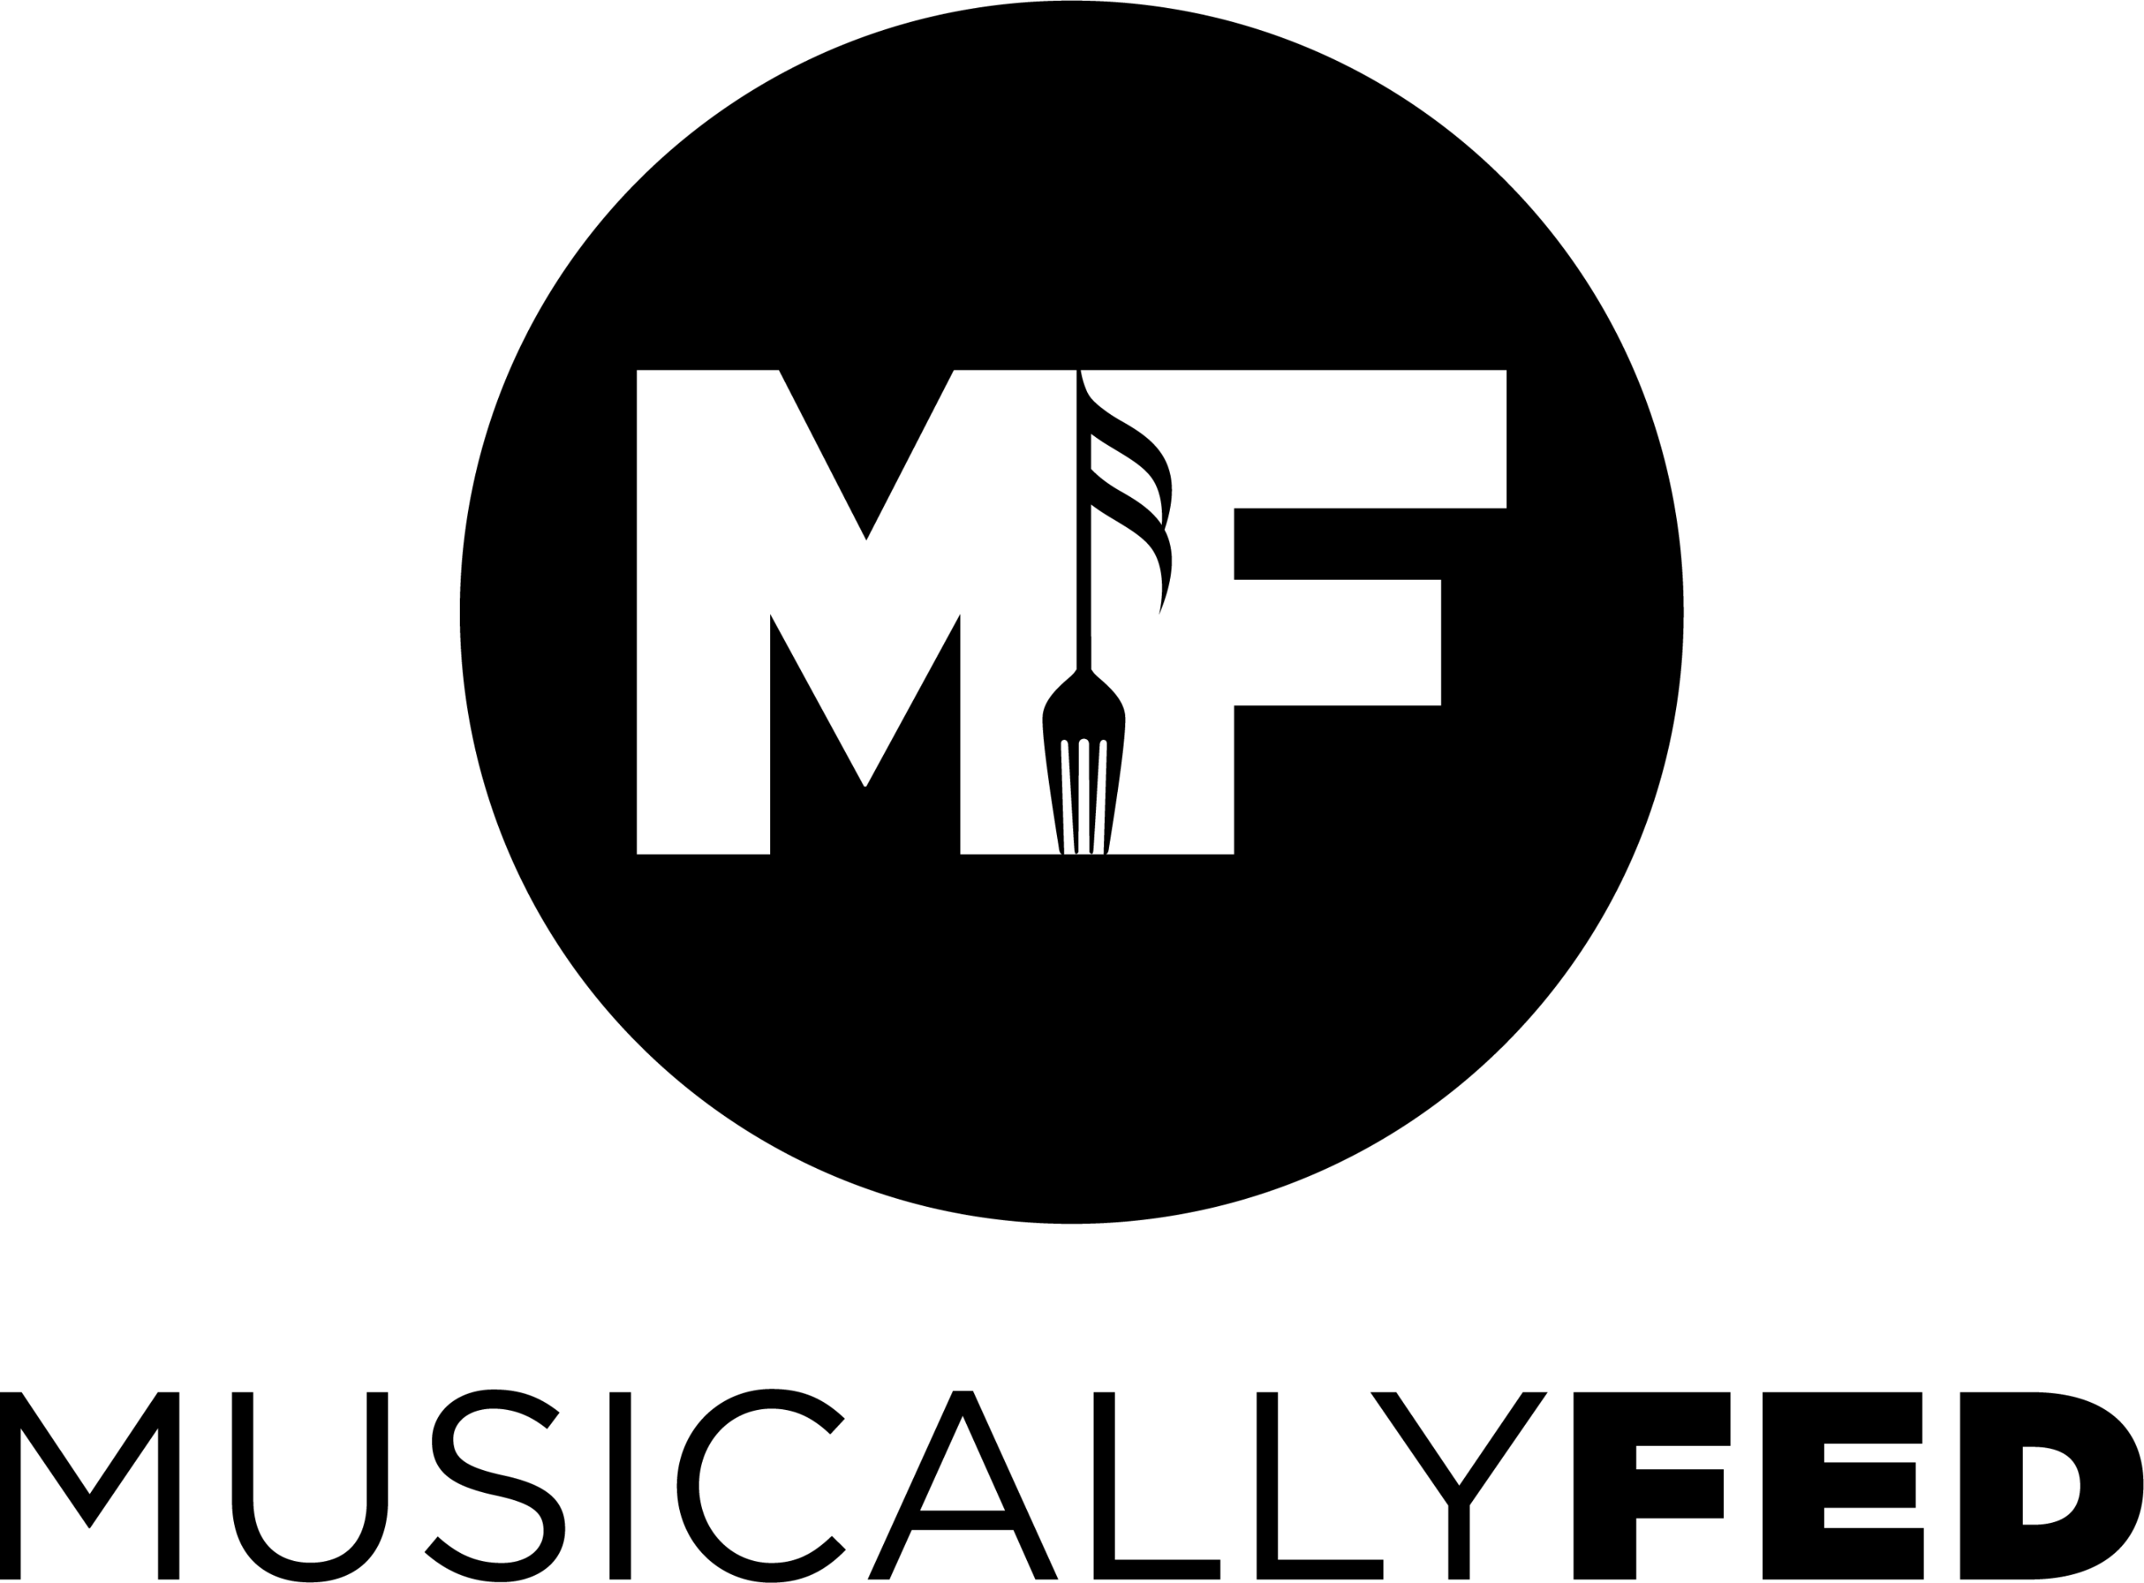
MEDIA RELEASE

Los Angeles Convention Center, Levy Restaurants & Musically Fed Impact 1000 Family Members
Bags of Groceries Provided to Students from Alliance of College-Ready Public Schools

(Los Angeles, CA Mar 24, 2020)— The Los Angeles Convention Center & Levy Restaurants teamed up last week with Musically Fed, donating and distributing 4,000 pounds of food to the Alliance College-Ready Public Schools benefiting students & their families grades 6-12.
Musically Fed, after being notified of another 4000-pound surplus, resulting from event cancellations, harnessed relationships garnered during its GRAMMY Awards initiative. In 24 hours, Musically Fed connected with Alliance facilitating a cooperative effort powered by LACC, Levy Restaurants and Musically Fed. This amalgamation of socially-minded organizations successfully provided several bags of free groceries for hundreds of students and their families.
“We are thrilled to share the success of this initiative,” said Ellen Schwartz, General Manager, Los Angeles Convention Center. “As a facility committed to sustainability and community service, Musically Fed was a perfect partner to further our goals to reduce our environmental footprint while serving those in need.”
COVID-19 school closures and the ravaged grocery shelves left in its wake, left many Alliance families ill-prepared due to both the depletion of available food and their dependence on the schools for daily sustenance.
“It was amazing to see how quickly everyone moved for a common good,” commented Jonathan Tiongco, Founding Principal for the Alliance Marine - Innovation & Technology 6-12 Complex, which is part of Alliance College-Ready Public Schools. “After a few texts, everyone sent out eblasts and posted to our Facebook parenting boards, 2 hours later, hundreds of families showed up with tears of joy in their eyes.”
“Schools and at-risk populations have been all the more acutely impacted by this pandemic,” commented Musically Fed’s CEO, Maria Brunner. “Our amazing partnership with Levy Restaurants and the Los Angeles Convention Center, provides a beacon of light from civic-minded organizations; leveraging their resources and compassion to positively impact so many families, during this otherwise dark time.”
“At Levy, we are continuously looking for new ways to help and give back to the community whenever we can,” said Patrick Smart, General Manager, Taste of LA by Levy, LACC. “Working with Musically Fed during GRAMMYS was such a great experience, we knew they would be the best group to call when we were looking to repurpose food, and ensure our community was benefiting from our donation.”
The novel challenges created by COVID-19 also provides opportunities to assist vulnerable community members most severely impacted by the social distancing and quarantine much more acutely. Those looking to distribute excess food can contact Musically Fed for assistance with logistics in getting items to those in great need. Please contact Musically Fed at info@musicallyfed.org or 480-951-1882.
To Donate to Musically Fed: www.musicallyfed.org

About Musically Fed:
Musically Fed is a nonprofit that works with artists, promoters, management, and venues nationwide to donate unused, backstage meals to community organizations comprised of at least 50% veterans and focus on feeding the homeless, hungry, and food insecure. We work to mobilize the music industry in the fight against hunger and identify opportunities, procure the resources, and coordinate all aspects of food handling, transport, and distribution. Our goal is to make it easy for promoters and performers to leave each city they visit with a lasting, positive impact.

Musically Fed receives no government funds and exists because of individual and corporate donations. Those passionate about ending hunger can contribute to this life saving work at www.musicallyfed.org.

About the Los Angeles Convention Center:
The Los Angeles Convention Center (LACC) is renowned internationally as a prime site for conventions, trade shows, and exhibitions. Owned by the City of Los Angeles and professionally managed by ASM Global, the LACC attracts over 2.5 million visitors annually. The facility is an integral economic component to the Southern California area, generating economic benefits through attendee direct and indirect spending and sustaining over 12,500 local jobs. The LACC also remains an enduring symbol of environmental sustainability and social responsibility and is proud to be a LEED® Gold certified facility; the venue was recertified on the Gold level in 2015 making the LACC the first convention center of its size in the U.S. to receive LEED® EB:O+M Gold recertification. For more information, please visit lacclink.com.

About the Alliance for College-Ready Public Schools:
Alliance College-Ready Public Schools is one of the largest and most successful nonprofit public charter school networks in the nation, operating 25 high-performing, public charter middle and high schools that educate nearly 13,000 scholars from Los Angeles’ most underserved communities. Alliance schools have been recognized as among the best in the nation by US News & World Report, Newsweek, the U.S. Department of Education and the California Department of Education. Since opening its first school in 2004, 95% of Alliance scholars have graduated from high school and been accepted to college.

# # #
Contact:
LACC
Michelle Riehle-Ludtke
213.765.4664
mriehle@lacclink.com

Musically Fed
Andrea Kramer
602.617.8640
kramer67@mac.com

Levy Restaurants
Ashley Russo
213.765.4480
arusso@Levyrestaurants.com

Catherine Suitor
Executive Director,
Alliance College-Ready Public Schools Foundation
424-264-3432
csuitor@laalliancefoundation.org

